**Embed Clickable Web Links in PDF Headers Using Syncfusion Essential**® **PDF in C#**

Syncfusion Essential® PDF is a powerful [.NET library](https://www.syncfusion.com/document-processing/pdf-framework/net) for creating, reading, and editing PDF documents. This guide shows you how to add a PdfTextWebLink in the PDF header using C# to create interactive, clickable links without Adobe dependencies.

**Steps to add a PdfTextWebLink in the PDF header**

**1.** **Set Up Your Project:** Create a new console application project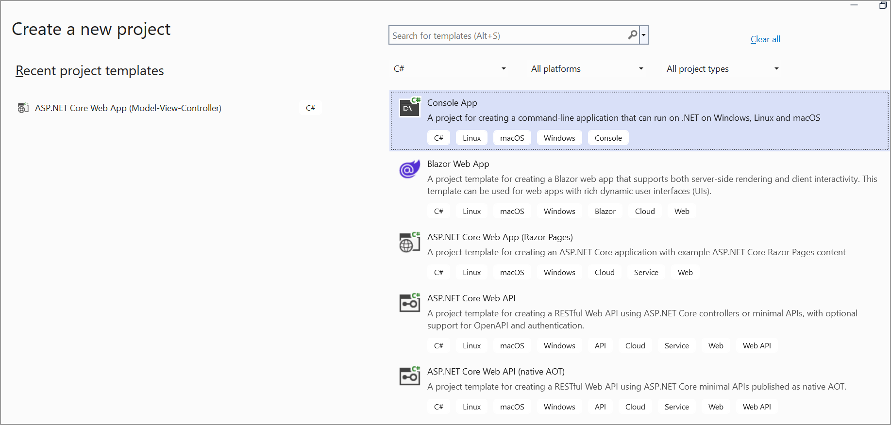

2. **Install the Syncfusion Package**: Add the [Syncfusion.Pdf.Net.Core](https://www.nuget.org/packages/Syncfusion.Pdf.Net.Core) package from NuGet to your project.

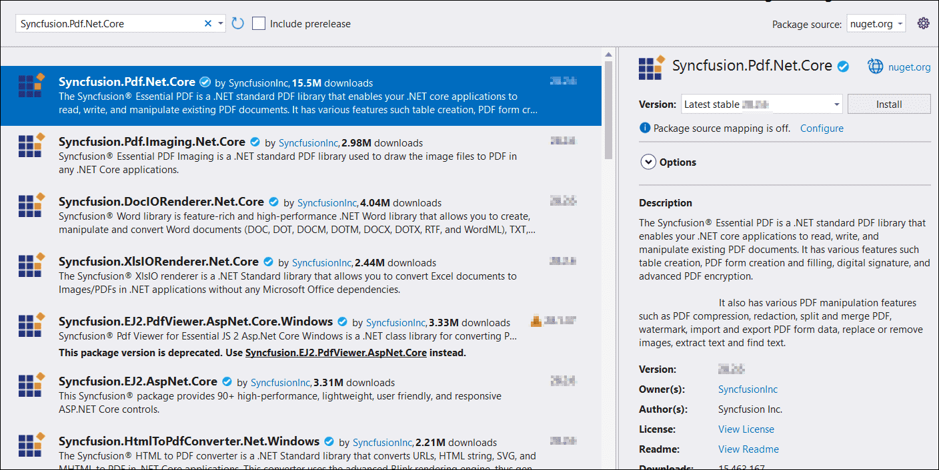

3. **Include Necessary Namespaces**: Add the following namespaces in **Program.cs**:

**C#**

|  |
| --- |
| using **Syncfusion**.Pdf.Graphics;  using **Syncfusion**.Pdf;  using **Syncfusion**.Drawing;  using **Syncfusion**.Pdf.Interactive; |

4. **Code Implementation**: Use the below code to embed a web link in the PDF header:

**C#**

|  |
| --- |
| // Create a new PDF document  PdfDocument document = new PdfDocument();  // Define the header text  string headerText = "Google";  // Create a font using the Helvetica typeface, size 12  PdfFont font = new PdfStandardFont(PdfFontFamily.Helvetica, 12);  // Measure the header text to get its size  SizeF headerTextSize = font.MeasureString(headerText);  // Create the header template element  PdfPageTemplateElement header = CreateHeader(headerText, font);  // Assign the header to the document's top template  document.Template.Top = header;  // Handle the PageAdded event to add a URI annotation to each new page  document.Pages.PageAdded += (sender, args) =>  {  // Create a URI annotation with the specified rectangle dimensions  PdfUriAnnotation uriAnnotation = new PdfUriAnnotation(new RectangleF(0, 0 - (header.Height - 10), headerTextSize.Width, headerTextSize.Height));  uriAnnotation.Text = "Google";  uriAnnotation.Uri = "https://www.google.com";  uriAnnotation.Border = new PdfAnnotationBorder(0);  args.Page.Annotations.Add(uriAnnotation);  };  // Add a new page to the document  PdfPage page = document.Pages.Add();  // Add another new page to the document  page = document.Pages.Add();  // Save the document to a memory stream  MemoryStream stream = new MemoryStream();  document.Save(stream);  document.Close(true);  // Write the contents of the memory stream to a file  File.WriteAllBytes("HyperLinkPDFHeader.pdf", stream.ToArray());  // Function to create the header  static PdfPageTemplateElement CreateHeader(string headerText, PdfFont font)  {  PdfPageTemplateElement header = new PdfPageTemplateElement(new RectangleF(0, 0, PdfPageSize.A4.Width, 50));  PdfBrush brush = new PdfSolidBrush(Color.Blue);  header.Graphics.DrawString(headerText, font, brush, new PointF(0, 10));  return header;  } |

A complete working sample can be downloaded from [**PdfTextWebLink_in_PDF_Header.zip**](https://www.syncfusion.com/downloads/support/directtrac/general/ze/PdfTextWebLink_in_PDF_Header-2109809539.zip)

By executing the program, the output PDF document will be generated as shown below:

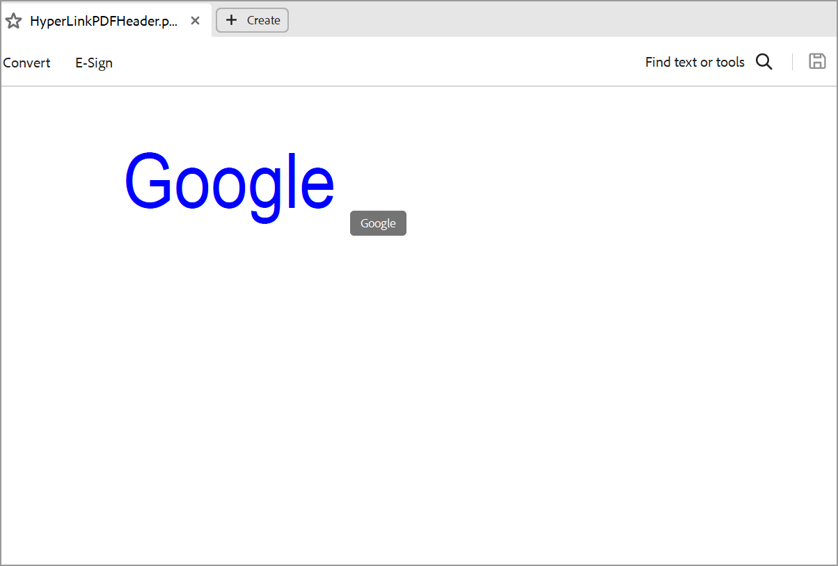

Take a moment to explore the [documentation](https://help.syncfusion.com/file-formats/pdf/working-with-headers-and-footers), where you can find detailed guidance and code examples for adding headers and footers to a PDF document.

**Conclusion**

I hope you enjoyed learning about how to add a PdfTextWebLink in the PDF header .

You can refer to our [**ASP.NET Core PDF**](https://www.syncfusion.com/document-processing/pdf-framework/net-core) feature tour page to know about its other groundbreaking feature representations and [**documentation**](https://help.syncfusion.com/aspnet-core/pdf/getting-started), and how to quickly get started for configuration specifications. You can also explore our [**ASP.NET Core PDF example**](https://www.syncfusion.com/demos/fileformats/pdf-library) to understand how to create and manipulate data in the .NET PDF.

For current customers, you can check out our Document processing libraries from the [**License and Downloads**](https://www.syncfusion.com/account/downloads) page. If you are new to Syncfusion®, you can try our 30-day [**free trial**](https://www.syncfusion.com/downloads/aspnetcore-js2) to check out our ASP.NET Core PDF and other .NET Core controls.